Scenario M3: Conceptual Node Overview:

The conceptual node is an EMF abstraction representing a collection of artifacts. Nodes can be linked together representing “communication”. They can also be linked to by artifacts (i.e. such as application components: melder’s design) providing a collection relationship between other linked artifacts. In levels of refinement node abstraction solidifies enabling progressive validation. In the following initial design we will discuss solutions of implementation using existing and or new API.

Vocabulary (today):

Links:

Dependency link: Source: requirement target: capability

Hosting link: source: unit: target: unit (matching on requirements\capacities)

Member link: collection of units hosted on a group.

Unit link: source: Unit target Unit ; parent of hosting and member links.

Logical link: source: DMO target: DMO

Other:

Unit: model introduces requirement and capability concepts.

DepoloyModuleObject (DMO) – parent of core models– common resolving defined here.

Discussion:

(From the M3 scenario: https://radical.raleigh.ibm.com/daisy/main/20771.html )

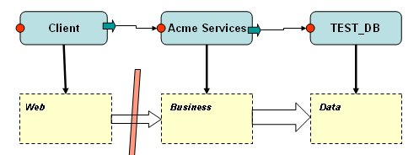

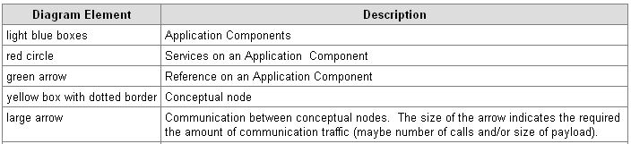

Using a divide and conquer approach, this is broken up into smaller problems with a focus on the M3 scenario and lineitem requirements. These problems include defining the conceptual node, interaction between the nodes, and the interaction between external (application component) artifacts.

Conceptual node: As mentioned above its main purpose is to group a collection of artifacts.

There are several thoughts on how to implement the Conceptual Node.

- The Conceptual node extends DeployModelObject. It does not have any template associated with it nor the notion of requirements and capabilities. It is basically a beacon for patterns like validation.
- Conceptual node extends unit which understands requirements and capabilities. This would allow for reuse of existing API. It would also allow for modeling of non functional requirements, which fits into the AWB scenario.
- A Conceptual node could be any unit. The unit object would have an attribute that would flag it as conceptual. This would allow for morphing or refactoring from a concrete artifact to a conceptual node while capturing non functional requirements.

UI Implementation
- Lollypop indicator will always appear on the conceptual units.

Conclusion: use step 3.

Interaction between the nodes: Nodes need the ability to link to other nodes. In this scenario it makes sense to talk about the linkage in terms of communication.

There are two thoughts here:
- Create a new Conceptual link that extends the Dependency link. The Conceptual link would have the following attributes: type, source and target. On linkage between nodes a conceptual requirement and a conceptual capability would be added to the units and be cached as the source and target attributes. On deletation of the link requirement and capability would be removed from the units. This matching code would be special cased to respect the conceptual node.
- Create a new Conceptual link that extends Logical link or an abstract of logical link. Logical links can connect to any DMO. The conceptual link would have the following attributes: type, source: unit and target: unit. This allows flexibility in linking without having to add requirements and capabilities. Matching code would not run on this code.

Validation implementation:
-Handles dependency links on the application level corresponding to the conceptual nodes business level. Errors would appear only on the Business level.

Conclusion use step 1.

* notes

Interaction between application components and the nodes

Nodes need the ability to link to by other artifacts, such as and application components. In this scenario we will use the term hosting link.

There are two thoughts here:
- Create a new Conceptual link that extends the hosting link. The Conceptual link would have the following attributes: type, source and target. On linkage between nodes a conceptual requirement and conceptual capability would be add to the units and be cached as the source and target attributes. On deletation of the link requirement and capability would be removed from the units. This matching code would be special cased to respect the conceptual node.
- Create a new Conceptual link that extends Logical link. Logical links can connect to any DMO. The conceptual link would have the following attributes: type, source: unit and target: unit. This allows flexibility in linking without having to add requirements and capabilities. Matching code would not run on this code.

Validation implementation:
-Handles hosting links on the application level corresponding to the conceptual nodes business level. Errors would appear only on the Business level.

Conclusion use step 1.

Questions: should some domains be turned off for M3?

